**CPU Simulator (Phrase IV) Documentation**

**User Guide**

1. The computer starts automatically when you open the Jar file.
2. Select a program to execute by clicking the radio button. The default program is Program2.

Mac OS:Users:macbookpro:Desktop:Screen Shot 2014-05-10 at 7.24.04 PM.png

Figure 1. Select a Program

**Running Program-2**

1. Input 10 strings by either pressing keys from the actual keyboard or clicking the buttons from the virtual keyboard.
2. After pressing or clicking “ENTER” button for every input, the simulator prints the data you input. Repeat this step 10 times. Register-0 works as a counter for user to check how many inputs you have been left.

Mac OS:Users:macbookpro:Desktop:Screen Shot 2014-05-10 at 8.19.30 PM.png

Figure 2: RO holds the counter

1. The simulator prints out the separator (******) after you finish to input 10 strings. (Stop providing data after you see ******)
2. Wait the simulator for sorting 10 strings.
3. The separator (******) will display when the sorting is completed.
4. Provide a search keyword after you see “ _?” on the printer.
5. If string is on your list, it will be printed out again. If not, program will terminate. Please see Figure-3 for the printer’s data explanations

Figure 3: Output of the Program-2



Word is printed if it is on the list

Input a keyword to search in the list

Sorting Finished

Sorting

Input Finished (Separator)

Input 10 strings

**Running Program-1**

1. Select Program-1 from the radio button on the top of the Control Panel. Press IPL button to run Program-1. As soon as IPL button is pressed, program asks user to provide first data while register MAR and MBR register changes continuously. (This means program loops to check if there is data in the keyboard buffer)
2. Input 20 integer numbers by clicking the on-board keyboard. After clicking “ENTER” button for every input, simulator prints the data provided. Continue this step until 20 inputs. Counter can be checked in the index register-1.

For example: 17, 11, 65, 28, 40, 77, 26, 91, 39, 85, 56 27, 38, 49, 91, 73, 9,45, 68,5

Mac OS:Users:macbookpro:Desktop:Screen Shot 2014-04-09 at 9.15.36 PM.png

Figure 4: IX1 holds the counter

1. The simulator prints out 111111 after user finishes to provide 20 input. (Stop providing data after you see first 111111)
2. Wait the simulator for sorting the 20 numbers.
3. Another 111111 will display when the sorting is completed.
4. Users must input another number for identifying its location.
5. The number before and after this number will be printed out.

(Please see Figure-5 below for the printer’s data explanations)

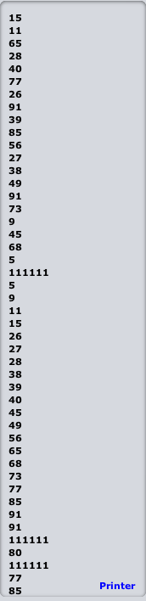

Input finished

Input

Finished

Input a number to identify the location

Sort

Finished

2 Numbers

Before and After the Input number

Sorting

Input 20 numbers